Profile
At K S School of Engineering and Management, the Department of Physical Education & Sports is a cell of major activity in the Campus. The Department of Physical Education & Sports is well equipped with modern infrastructure. The department encourage all kind of sports activities like Athletics, Cricket, Volleyball, Football, Basketball, Badminton, Table Tennis, Chess, Carrom, Yoga, Martial Arts etc. Plenty of encouragement and opportunities are given to the students to participate in different sports. Students of KSSEM actively participate in Inter-Collegiate Sports and Games organized by VTU and other organizations.

Head Of The Department Desk
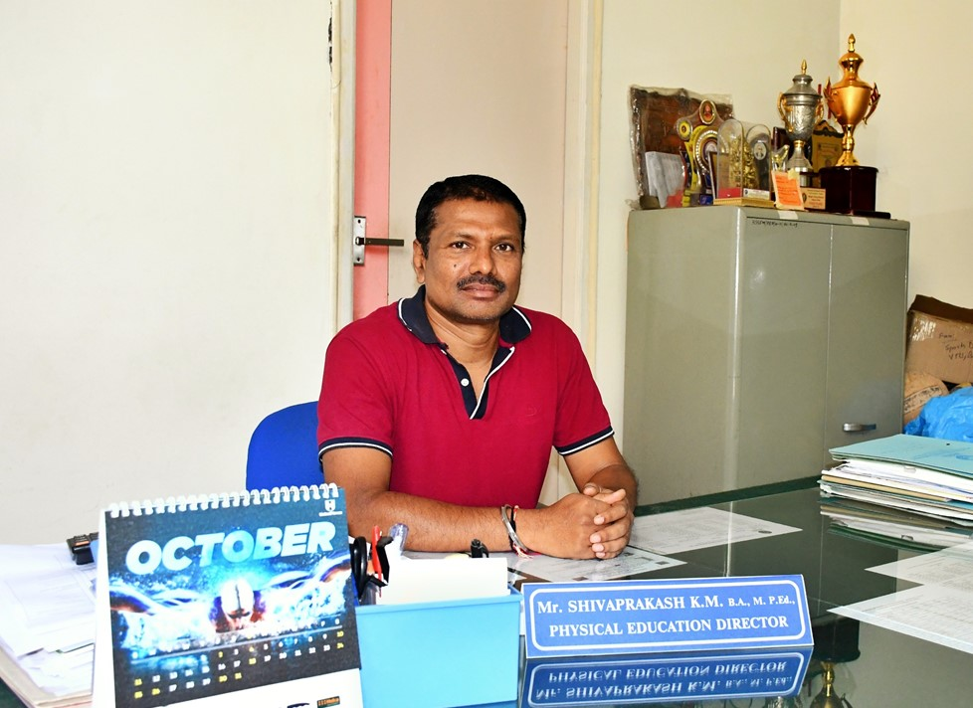

Mr. Shivaprakash K. M

Physical Education Director

B.A, M.P Ed
Message: Physical Education is one of the important aspects of an educational programme. Physical Education produces, in a person, frequent bouts of physical activity throughout the day, which yields short-term benefits for mental and cognitive health, while also providing opportunities to practice skills and building confidence that promotes ongoing engagement in physical activity.
The four main objectives of physical education are improved physical fitness, appreciation of physical activity, sportsmanship development and improved social skills.
The department of Physical Education at K S School of Engineering and Management gives opportunities to the students to participate in activities which help the students develop a holistic approach. Our students have participated in various tournaments conducted by V.T.U, Universities all over India, and at District, State & National events and have brought laurels to their institution.

Contact :
Mobile no: +91 9448226326
E-mail: kssemsports@gmail.com
Area of Specialization: Cricket, Kabaddi, Kho-Kho, Badminton & Athletics.

Vision
- To provide extracurricular, recreational facilities and to enhance physical and mental well being of students and staff.

Mission
Department of Physical Education shall
- Encourage sporting and promoting the sporting talents
- Instill the sportsman spirit and discipline.

Values
- Being aware of the respect for individual differences, we promote professional, Social and ethical responsibility.

HIGHLIGHTS OF DEPARTMENT
- Organised VTU Bengaluru South zone Table Tennis Tournament for Men & Women on 7th & 8th Sept 2015.
- Organised National Conference in Physical Education on 5th May 2015.
- Annual Sports Day for students and staff are held during the even semester every year.
- We will provide sports T- Shirt to all for Sports Day.
- We will invite KSSEM Sports Alumni (University or state level prize winners ) as guests to the sports day function, in order to motivate our students.
- During the day-long programme, students and staff take part in the march past, oath taking ceremony and athletic events, and we will provide medals and certificates to the winners.
- Physical Education Department provides Individual championship trophies for Boys and Girls, based on high scores in the points tables.
- University and State level prize winners, and the Players who represent VTU at University level will be honoured by the guest.
- Krida-Ratna Award are also awarded to the out-going students who have actively participated in, and won the medals at inter-collegiate and university level .
- The Principal and Management are very supportive of the Athletes & Artists who take part in sports and cultural activities.
- Cash prizes are also awarded to the Winners from the institution in VTU Inter-Collegiate competitions.
- Students are very active, interested and dedicated and make use all the facilities provided by the management through the Department of Physical Education and Sports Science. They have left no stones unturned in bringing laurels to the college.
- Director, Physical Education of KSSEM was nominated as one of the selection committee members, to select the University Central Karnataka Zone Cricket (M) team for the Inter University tournament 2019-20, held at JNN College of Engineering, Shivamogga on 3rd & 4th Oct 2019.
- Director, Physical Education of KSSEM was nominated as Coach for the University Soft Ball women?s team at the 2018-19 Inter University tournament held from 2nd to 5th March 2019 at Calicut University, Kerala.
- Director, Physical Education of KSSEM was nominated as Coach for VTU Archery team at the All India Inter University Archery Tournament held at Punjabi University, Patiala from 22nd to 26th January 2016. The VTU team secured 3rd place in mixed doubles compound event.

Facilities
K S School Of Engineering and Management, Department of Physical Education & Sports is a cell of major activity in the Campus. The Department of Physical Education & Sports is well equipped with modern infrastructure and conducts activities like Basketball, Volleyball, Badminton, Table Tennis, Cricket, Handball, Football, Netball, Chess, and Athletics. Sports are in fact a way of life for the student's health and fitness and those looking for professional star status. Physical education, a learning experience, offers a unique opportunity for problem solving, self-expression and socialization. A well-implemented, comprehensive programme is an essential component for the growth of both mind and body

Out-door sports
- Cricket
- Football
- Basket ball
- Volley ball
- Throw ball
- Kabaddi
- Hand ball
- Kho-Kho

In-door sports
- Chess
- Carrom
- Table Tennis
- Badminton
- Gym

ENCOURAGING SPORTS ACTIVITES
We will encourage all kind of sports activities like:
- ARCHERY , ATHLETICS
- BADMINTON , BOXING
- BALL BADMINTON
- BASKET BALL
- CRICKET, CYCLING , CHESS
- CROSS COUNTRY RACE
- FOOTBALL, FENCING
- GYMNASTICS
- HAND BALL , HOCKEY
- JUDO, TAIKANDA
- KABADDI , KHO ? KHO
- NETBALL
- SOFT BALL, SQUASH ROCKET
- SWIMMING, SHOOTING
- SKATING
- TENNIS , TABLE TENNIS
- THROW BALL , TUG OF WAR
- VOLLEY BALL
- WRESTLING
- WEIGHT , POWER LIFTING & BEST PHYSIQUE (MEN)
- YOGA , YOUTH FESTIVAL

Interdepartmental Sports 2024-25
"Interdepartmental sports organized at KSSEM from 19th Nov to 7th Dec 2024 "
2024-11-19

Interdepartmental Sports 2024-25
"Interdepartmental sports organized at KSSEM from 19th Nov to 7th Dec 2024"
2024-11-19

Interdepartmental Sports 2024-25
"Interdepartmental sports organized at KSSEM from 19th Nov to 7th Dec 2024"
2024-11-19

Interdepartmental Sports 2024-25
"Interdepartmental sports organized at KSSEM from 19th Nov to 7th Dec 2024"
2024-11-19

Throwball
"VTU Bangalore South Division Inter College Throwball (W) tournament 2024-25 held at JVIT, Bidadi on 12th Dec 2024.They played against RRCE. "
2024-12-12

Volleyball
"VTU Bangalore South Division Inter College Volleyball (M) Tournament 2024-25 held at ACSCE, Bengaluru on 22nd & 23rd Nov 2024. KSSEM students played against DSCE, Bengaluru. "
2024-11-22

Kabaddi
"VTU , Intercollegiate Bengaluru South Division Kabaddi tournament held at Sri Sairam CE , Anekal on 19th Oct 2024. 1st match we own against DSCE & 2nd match played against DBIT."
2024-10-19

Basket ball
"VTU , Intercollegiate Bengaluru South Division Basket ball tournament held at T. John IT, on 18th Oct 2024 and played against RNSIT."
2024-10-18

Cricket
"VtU , Intercollegiate Bengaluru South Division Cricket tournament held at SJBIT on 6th Oct 2024 and played against AMCE."
2024-10-06

Chess
"VTU, State level Chess Competition 2024-25 held at BMSCE, Bangalore on 16th & 17th July 2024. KSSEM, Chess (M) team participated in this competition."
2024-07-16

Powerlifting
"VTU, State level Power lifting Competition 2024-25 held at New horizon College, Bangalore on 10th & 11th July 2024. July 2024. KSSEM, team participated in this competition. "
2024-07-10

Badminton
"VTU Bangalore South Division Inter Collegiate Badminton (M&W) Tournament held at RVATM , Bengaluru on 8th & 9th July 2024, KSSEM , team participated in this tournament."
2024-07-08

Table Tennis
"VTU Bangalore South Division Inter Collegiate Table tennis (M&W) Tournament held at SJBIT , Bengaluru on 2nd and 3rd July 2024 , KSSEM , team participated in this tournament."
2024-07-20

Athletic
"25th VTU Inter Collegiate state level Athletic Meet -2023-24 held at VTU Campus Mysore on 26th to 29th Jun 2024, participated in these events."
2024-06-26

Swimming
"B Nayana, 6th CSE (1KG21CS014) secured bronze medal in 400Mts free style .The VTU, State level Swimming (M &W) competition organized by RVITM, Bangalore at Basavanagudi Aquatic centre , Bengaluru on 19th & 20th June 2024 . "
2024-06-19

B NAYANA ,6th Sem CSE
2024-06-19
B NAYANA , 6th sem , 1KG21CS014, Department of CSE Secured Bronze Medal in 400Mts free style .The VTU, State level Swimming Competition Organized by RVITM, Bangalore at Basavanagudi Aquatic center on 19th & 20th June 2024.

B Nayana 4th sem CSE
2023-08-09
secured 5 bronze medal 100M Free Style, 200M Free Style,400M Free Style 800M Free Style & 200M IM in the VTU State Level swimming competition 2023 held at MSRIT Bangalore 9th August 2023.

Gagana Sree 4th sem Dept. Of MBA
2022-06-30
secured Bronze Medal Javelin Throw in VTU Inter Collegiate 2021-22, held at 27th June to 30th June 2022 SJCIT Chikkaballapura.

State Level Achievers

Prajwal Department of AI&DS
2023-09-10
Prajwal CL , 5th sem , 1KG21AD036, Department of AI&DS Secured Gold medal in the Karnataka State Senior Dodgeball Championship held on 10th Sept2023. Organised by Dorgeball Association of Karnataka , Affiliated to Dorgeball Federation of India.

National Level Achievers

Monith Gowda CN, Department of ECE , 5th sem
2024-10-09
Monith Gowda CN, 1KG22EC072, Department of ECE 5th sem , Represented Volleyball Association of Karnataka, Secured 1st place in the 11th South Zone National level Invitational Volleyball Championship 2024, held at Puducherry State from 9th to 11th Oct 2024.

